BIG/SMALL:
Colour the big fish:
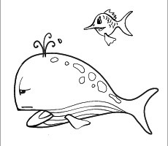

Colout the small pencil:

